Задание 40 (образец):

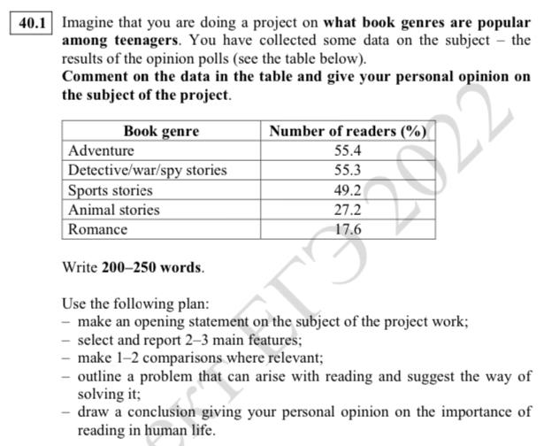
Примерный ответ:

абзац 1: make an opening statement on the subject of the project work  1. Общая фраза по общей теме (reading).  2. Важность конкретной темы (what book genres are popular among teenagers).  3. Подготовка проекта по этой теме.  4. Таблица со статистикой. | Reading is an important part of education and if parents and teachers want to encourage teenagers to read, they need to know what kinds of books most appeal to young people. My project, which I am still working on, is aimed at finding out what book genres are popular with teenage boys and girls. I have found some data on this issue and organised it in the table below.
абзац 2: select and report 2–3 main features  Пишем о самом большом и самом маленьком показателях | I can identify two main features of the statistics presented in the table. The first one is that the majority of teenagers cited adventure stories as their favourite book genre, making this kind of books most popular among young people. And the second key feature is that only 17.6 per cent of teenagers reported enjoying reading romances, putting this genre at the bottom of the table.
абзац 3: make 1–2 comparisons where relevant  сравниваем | It is also worth mentioning that the number of teenagers enjoying detective novels and books about war and spies (55,3%) is only slightly lower than the number of teenagers enjoying adventure stories (55,4%).
абзац 4: outline a problem that can arise with reading and suggest the way of solving it  Находим проблему и предлагаем способы её решения | In my opinion, the statistics in the table reveal an important problem. We can see that teenagers are not interested in biographies and are therefore missing out on a great amount of wisdom contained in these books. I think that in order to solve this problem biographies should be included in the school curriculum.
абзац 5: draw a conclusion giving your personal opinion on the importance of reading in human life.  Личное мнение + аргументы | In conclusion, I believe that reading is important for people of all ages. Not only is reading fun and enjoyable, but it also allows us to learn about any subject and improve our analytical and creative skills.  258 words

