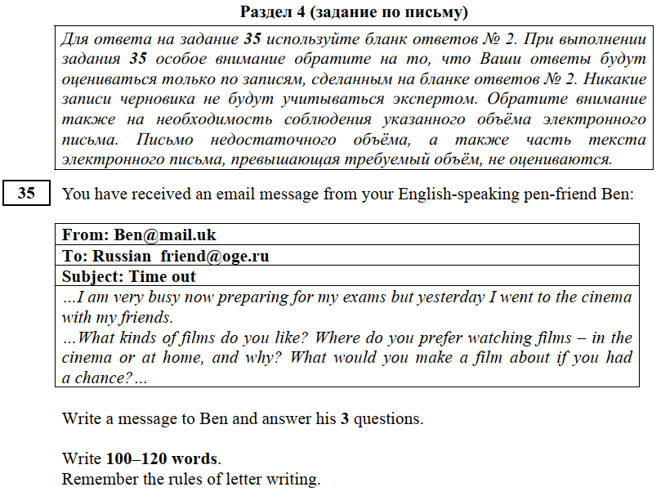

From: Russian_friend@oge.ru
To: Ben@mail.uk
Subject: Time out

Dear Ben,
Thank you for your message / email. I hope you’re doing well.
You asked me to tell you about the movies I like. Well, I love comedies, they are my favorite movie genre. For me, there is nothing better than staying at home and watching a good comedy with my family. We always eat pizza and laugh out loud when we watch comedies together. It's so much fun! We can't really do that at the cinema because we'll disturb and annoy other people. I guess if I had a chance, I would make a film about my family. Recording family history seems a great idea.
Write again when you have time.
All the best,
Mary

- Адрес НЕ нужен
- Красные сроки + абзацы (6шт)
- Благодарность за письмо
- Ответы на вопросы ВСЕ в одном абзаце
- Свои вопросы НЕ нужны (база гум (5-9 классы)
- Надежда на последующие контакты

5 th grade - 80-100
6th grade - 90-120
7-9 - 100-120

https://vk.com/egexpert

9-10 - «5»
7-8 - «4»
5-6 - «3»
4-0 - «2»
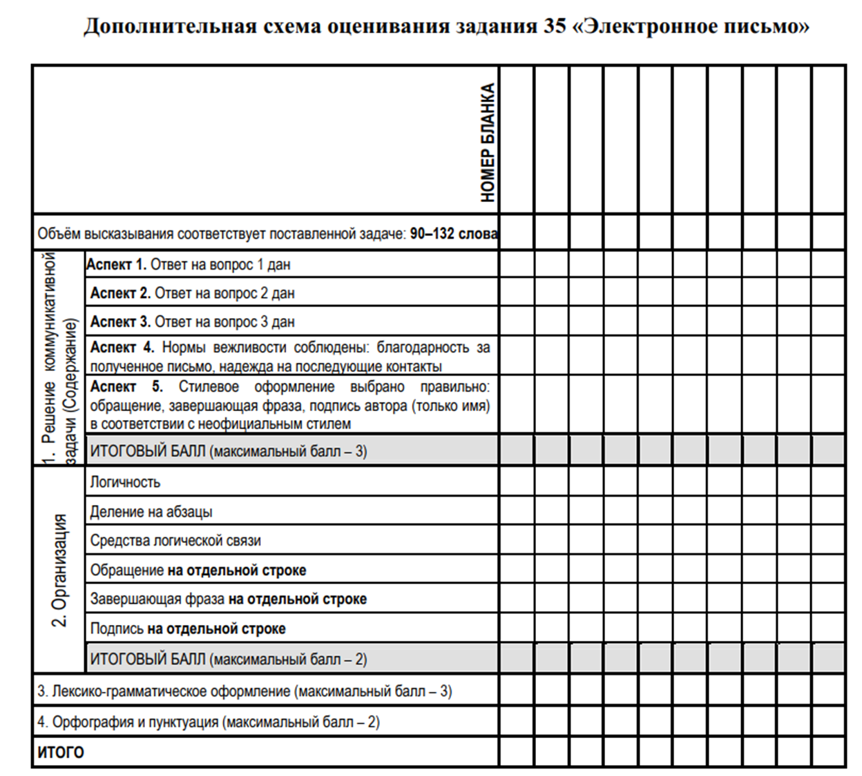
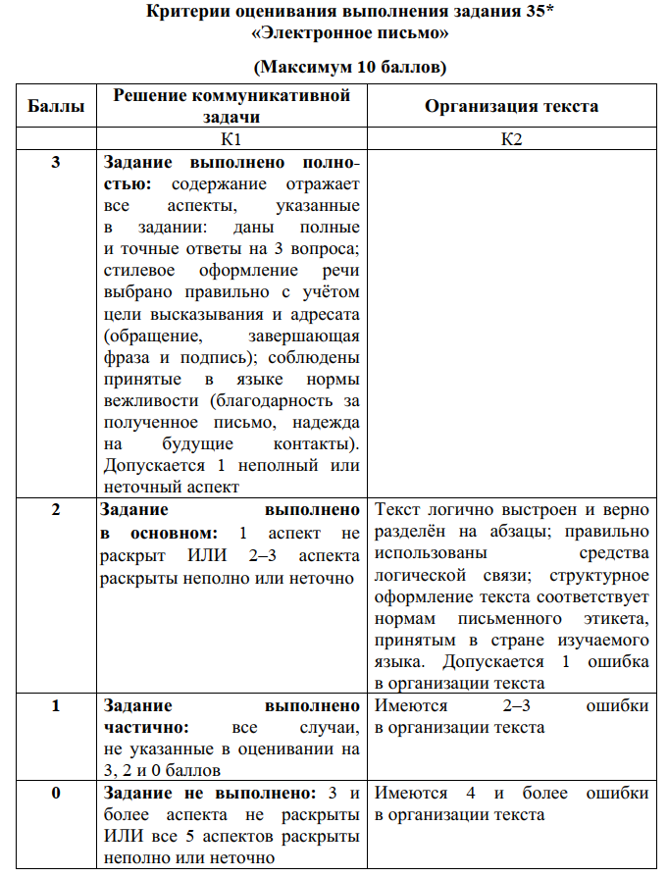 | 