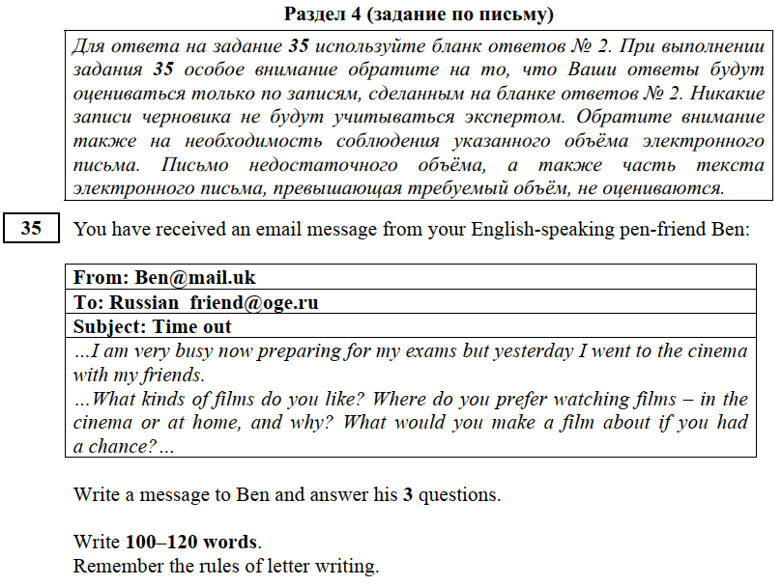

From: Russian_friend@oge.ru
To: Ben@mail.uk
Subject: Time out

Dear Ben,
Thanks for your message / email. Hope everything is all right./Hope you’re doing well.
You asked me 3 questions./ In your last email you asked me about….Well, ……………………………………………………………………………………………………………………………………………………………………………………………………………………………………………………………………………………………………………………………………………………………………………………………………………………………………………………………………………………………………….
Write back when you have time. / Drop me a message when you can. / Write again soon.
All the best,
Оценка
9-10 - «5»
7-8 - «4»
5-6 - «3»
4-0 - «2»

- Адрес НЕ нужен
- Красные сроки + абзацы (6шт)
- Благодарность за письмо
- Ответы на вопросы ВСЕ в одном абзаце
- Свои вопросы НЕ нужны
- Надежда на последующие контакты

5 th grade - 80-100
6th grade - 90-120
7-9th grade - 100-120

Love,
Lots of love,
All my love,
Best wishes,
With the best wishes,
Mary

https://vk.com/egexpert

9-10 - «5»
7-8 - «4»
5-6 - «3»
4-0 - «2»
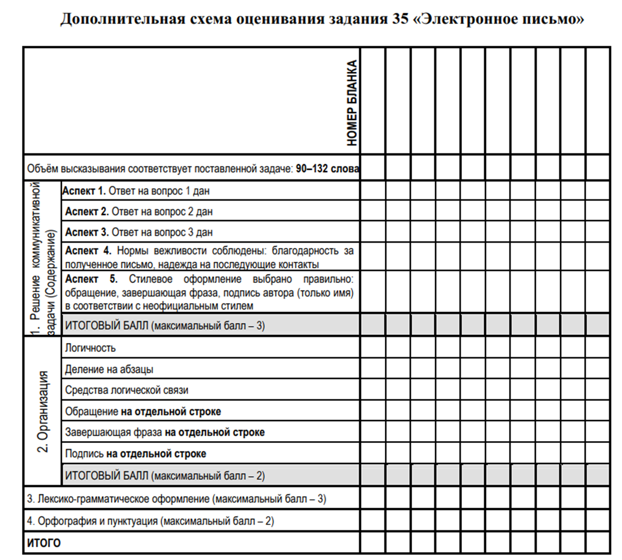
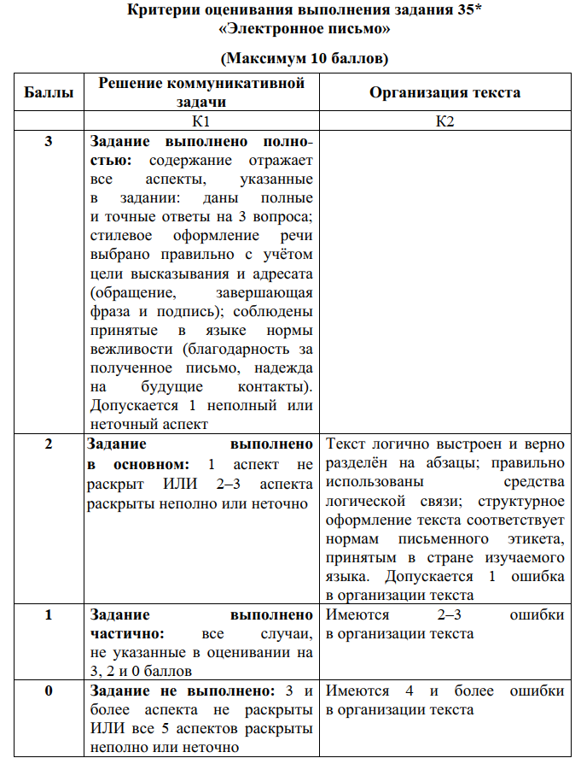 | 